
The
Terrotarian
Rotary Club of Darwin
GPO Box 879 Darwin NT Australia 0801

The First Rotary Club in the Northern Territory, chartered 8 September 1958. Sponsored by the RC of Port Adelaide SA, we are in turn the sponsoring Club of the Darwin North, Nhulunbuy and Dili Rotary Clubs.
We are also the sponsoring Club of the Interact Club of Darwin High School.

June is Fellowship Month


THE 4 WAY TEST ROTARY GRACE
Is it the truth? O Lord and giver of all good
Is it fair to all concerned? We thank you for our daily food
Will it build goodwill and better friendships? May Rotary friends and Rotary ways
Will it be beneficial to all concerned? Help us serve thee all our days

EClub www.rotaryeclubone.com

R.I. District 9550 www.d9550rotary.org.au

Club President: Scott Perkins

Bulletin Editor: Iain Smith Club Website: www.darwinrotary.com

Apologies: Ben Hockley - 0413 993173 benhockley@gmail.com

Bulletin Meeting Date
52 (15/16) 2967 02/06/16

This Week

Erik Vandenberg – Cambodian Water Project

Henry Duncan – Testosterone: Myth or Magic

Next Week

Nicole Manison MLA, ALP Member for Wanguri – topic TBA

Duty Roster | This week | Next week
Meeting Notes | Henry Duncan | Andrew Pinnell
Attendance / Apologies | Ben Hockley | Ben Hockley
Rotary Grace | Wayne Nicholls | Hugh Bradley
Welcome to visitors | John Palamountain | Steve Baddeley
International Toast | Prath Prathapan | John Brears
Fellowship # 1 | Rob Trenerry | Geoff Cussen
Fellowship # 2 | Erik Vandenberg | Steven Camilleri
Fellowship # 3 | Rob Blakeway | Peter Davies
Introduction of Guest Speaker | N/A
Response to Guest Speaker | N/A | Dan Easton

Coming Week
Birthdays | Anniversaries
 | None recorded
  Wed 8 June, Felicity Electricity

Members  Present | Apologies | Makeups | Silent | Members’  Guests | Club  Guests | Visiting  Rotarians | Members  On Leave
29 (86%) | 17 | 1 | 3 | 2 | 1 | 2 | 4
 |  | Fines | Rotary Foundation
 |  | $195.60 | $40.10
Meal surplus banked: $70.00


Speedway Dates
Volunteers Required

4 Jun AMCA & Junior sedans Darwin title
11 Jun Sprint car/wingless & street stocks Darwin title
2 Jul Wingless, F500 Darwin title
30 Jul F500 NT Titles
19/20 Aug Bob Ekins Memorial
26/27 Aug Titles night

Previous Meeting
Mark Monaghan reports
Meeting opened by Pres Scott at 6.32pm. Rotary Grace led by Greg Need in absenting indium.
Visiting Rotarians: Rod Meyers (Darwin Sunrise), Barry Wilson (RC of Kiama and ROMAC Operations Director).
Member’s Guest: Bruce Lieshman
Club Guest: Amanda Gore, guest speaker at LLL.
Wayne Nichols welcomed the visitors and guests.
President’s Announcements:
- 18 June change over progressing well
- Ladies’ Long Lunch progressing well with 327 tickets sold
- Fingers is in hospital with some heart issues. Some cruel comments about how the doctors would know this when it’s debatable that his heart exists.
Secretary Ray reminded members about the invitation to Government House on 10 June
Treasurer Mick reported we were solvent and the break even for LLL is 300.
Community Services, International, Youth: no reports
John P reported on last board minute meeting: A submission for a Global Grant. grant for 4x4 vehicle for HealthLab has been prepared. We have requested help from overseas Clubs.
Ray is on 6 months leave.
Christine Smith has been selected to attend the world science conference. She has requested support from Rotary. We have agreed to $1000 in lieu of labour help at the Chocolate Wheel.
Car Show: There were 923 through the gate and we made $7000 for TRF.
Drag duty at the gate $400 and $700 four people volunteer Scruffy, Dan, Andrew and one other.
Fellowship Eric reported on a Project for clean water for Cambodia
Barry Wilson from Romac spoke about Rotary Oceania Medical Aid. Darwin is the most important port for Romac as 30-40% of patients from Timor Leste pass through Darwin before heading south to hospital. Rod meets and greets patients. We need more to go out to airport and put them on another plane.
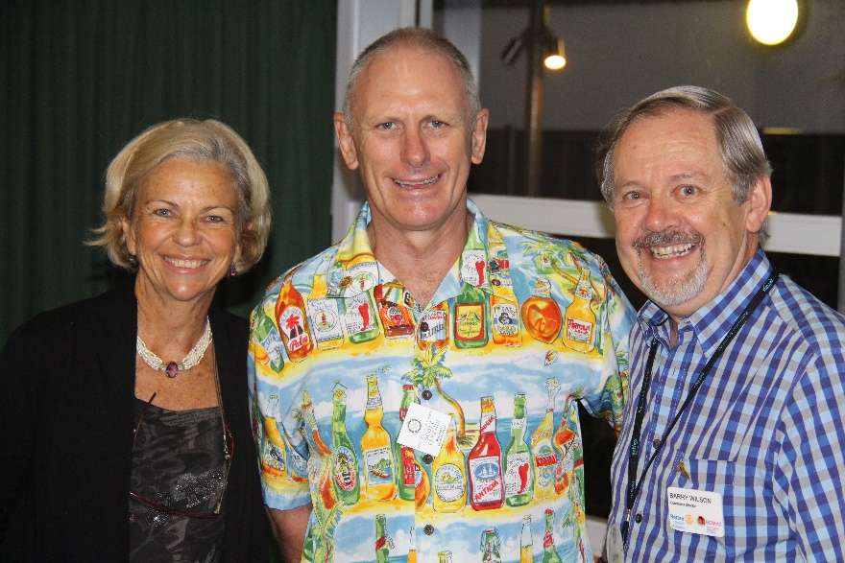
President Scott with Guest Speakers Amanda (the one on his right) and Barry.
Guest Speaker introduced by Scott Perkins. Amanda Gore is the keynote speaker at tomorrow's ladies lunch.
Amanda spoke about men getting together is good for our health. Friends make you healthy. She went on to explain some more about men’s health problems. Graham Williams specialises in hormones from 35 when we start to lose testosterone. Apparenly, our sex drive is last thing to go and we become fat, grumpy old men. (The Big E started grumping about women, at this stage) Graham can provide us with testosterone cream for $250.
If we have hearing issues Amanda suggested we don't go to audiologist...but go to Costco where you pay $1800 dollars for hearing aids. Amanda told us Kidman Park Primary School is trialling a school joy programme which is about students learning how to feel good about themselves. To date, detentions are down 55%. She invited us to visit them.
As Fingers didn't have the heart to turn up and thank the speakers, President Scott did the honours.
John Brears sent around confirmation of volunteer list for tomorrow’s LLL and put last call out. The lunch starts at 12.15. and members were asked to be there at 1145.
Grant Lindsay gave feedback on the BBQ for Australia Day. Thankyou to Scruffy and Jacko, Rob, John Brears and Scott.
Peter has 10 CD radio players that were donated 8 years ago. It was decided that they will be prizes for the Chocolate Wheel.
See Dan for the entertainment book.
Scruffy thanked all for thoughts on his dog.
Mark spoke about Give Me 5 For Kids – see www.giveme5forkids.com.au<http://www.giveme5forkids.com.au> They have a golf day on Friday and Mark is looking for golfers to join his team of 4. Palmerston Golf Club Friday. Ben will check his roster. Scott has signed on behalf of the club to run the raffle.
Project for health lab info has been circulated.
Andrew gave the International Toast to RC of Newcastle-on-Tyne. They meet on Fridays at 12.45 pm at the New Kent Hotel, 127 Osborne Road, Jesmond. The club is 100 years old, having been chartered on 20 August 1915, and have sponsored 25 clubs. Peter Tracey is President and they run a number of fundraisers to support three charities.

Sergeant’s fine session with Dan and Eric as corporals. The Sergeant was in fine form (Ed; hmm!), fining those wearing long trousers, those not assisting at LLL, those that didn’t compete in the Barra Classic on the weekend. As Tuesday was the International Dayto End Obstetric Fistula and fined all who had never suffered from the infirmity (plus all those who didn’t know what it was.) The guest speaker was also fined for “scaring us old men”.
President Scott thanked visitors and closed the meeting before the Harry Payne Memorial Joke. Time closed. 8.13pm.
Meeting reopened for HPMJ from Rob and then was re-closed one minute later.

Ladies Long Lunch
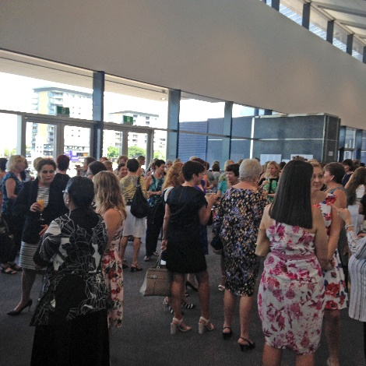
Well the big day finally arrived and some 330 ladies presented themselves in their Sunday finest to enjoy the food, company and guest speakers – and for the opportunity to spend some money.
A full and final report will appear next week but just a few notes from tour Acting Editor (who was present albeit as a back room boy).
I understand the event was successful from a social and financial view. Certainly the comments I overheard from some of the ladies as they were leaving attested to the former: while we don’t have final financial figures, the raffle appeared to more than break even, at least judging by the number of tickets we unstapled and placed in the barrel. And the size of the bids at auction augured well for a successful result.
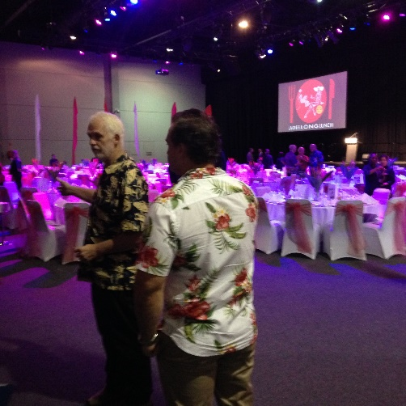
The ladies assemble for the fray…

While the men prepare

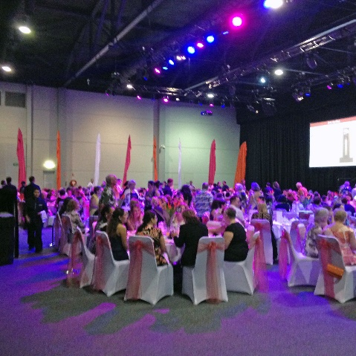
Amanda Gore started off quietly enough but before long she had a room full of ladies on their feet and going through all sorts of gymnastic feats. Meantime, the Rotarians present discreetly retired to the back room – didn’t want to get caught up in the (almost religious) fervour – we’d had enough the night before!

As a nod to Amanda’s health messages to us mere men, we present:
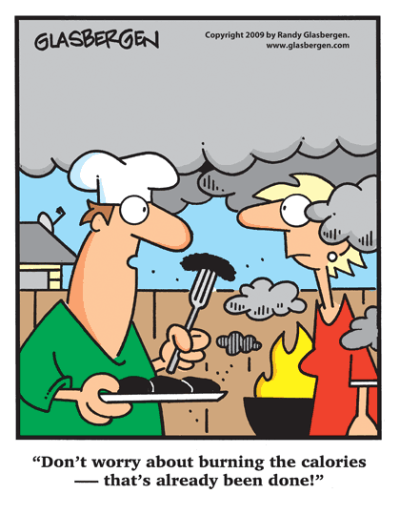

Did you hear the one about the very short fellow of Czechoslovakian descent who was being chased on a downtown street by a mobster? He was losing ground because his legs were so short, so he ducked into a bank to hide. To the startled teller he enquired: "Can you cache a small Czech?"

A woman was told by her doctor that she could not have any more children.
"Inconceivable," said a friend; "impregnable," said another; "unbearable," said a third.

And Matthew celebrates with his mates
In Dickens' era, there was an awful beast under London Bridge over the Thames River which sank boats, ate passengers, and generally wreaked havoc. Finally a brave group of knights lured it onto the beach and (with dreadful loss of life and limb) slew it. After the conquest, Sir Newt of Gingrich suggested they grind up the foul beast, make it into a sausage, and use it for food at the orphanage in place of expensive gruel. Thus Dickens' immortal opening line: "It was the beast of Thames; it was the wurst of Thames."

A small boy was lost at a large shopping mall.
He approached a uniformed policeman and said, "I've lost my grandpa."
The cop asked, "What's he like?"
The little boy replied, "Bundaberg rum and women with big tits."

Rotary Club of Darwin Presidents
1958/59 | Robbie Robbins | 1959/60 | Frank Hussey | 1960/61 | Jim Clape | 1961/62 | Lou de Courcey
1962/63 | Ken Slide | 1963/64 | Terry Irvine | 1964/65 | Keith Jarvis | 1965/66 | Clem Chilman
1966/67 | Max Tite PDG | 1967/68 | Ken Davidson | 1968/69 | Ken Graham | 1969/70 | Alf King
1970/71 | Ian MacGregor | 1971/72 | Bill McLaren | 1972/73 | Don Sanders | 1973/74 | Jim Hair
1974/75 | Barry Gascoyne | 1975/76 | Stan Haupt | 1976/77 | Sid Lauder | 1977/78 | Bob Glindeman
1978/79 | John Beagley PDG | 1979/80 | Jim Gallacher | 1980/81 | Tony Maryon | 1981/82 | Peter Wells
1982/83 | Dick Hosking | 1983/84 | Norm Russell | 1984/85 | Terry Piggott | 1985/86 | Stan Miller
1986/87 | Brian Woodrow | 1987/88 | Saus Grant | 1988/89 | Kerry Ambrose-Pearce | 1989/90 | Reg Lowry
1990/91 | Bob West | 1991/92 | Rowan Charrington | 1992/93 | Harry Payne | 1993/94 | Tony Jeffries
1994/95 | Kym Burgess | 1995/96 | John Hartree | 1996/97 | Wayne Nicholls | 1997/98 | John Hardy
1998/99 | Richard Merritt | 1999/00 | Ray Fauntleroy | 2000/01 | John Brears | 2001/02 | John Everett
2002/03 | John Emslie | 2003/04 | Ian Watts | 2004/05 | Grant Lindsay | 2005/06 | Martin Jolly
2006/07 | Patrick Wright | 2007/08 | Peter Hopton | 2008/09 | Wayne Nicholls | 2009/10 | John Palamountain
2010/11 | Jim McNally | 2011/12 | Peter Beirne | 2012/13 | Vic Minchin | 2013/14 | Rob Trenerry
2014/15 | Dan Easton | 2015/16 | Scott Perkins

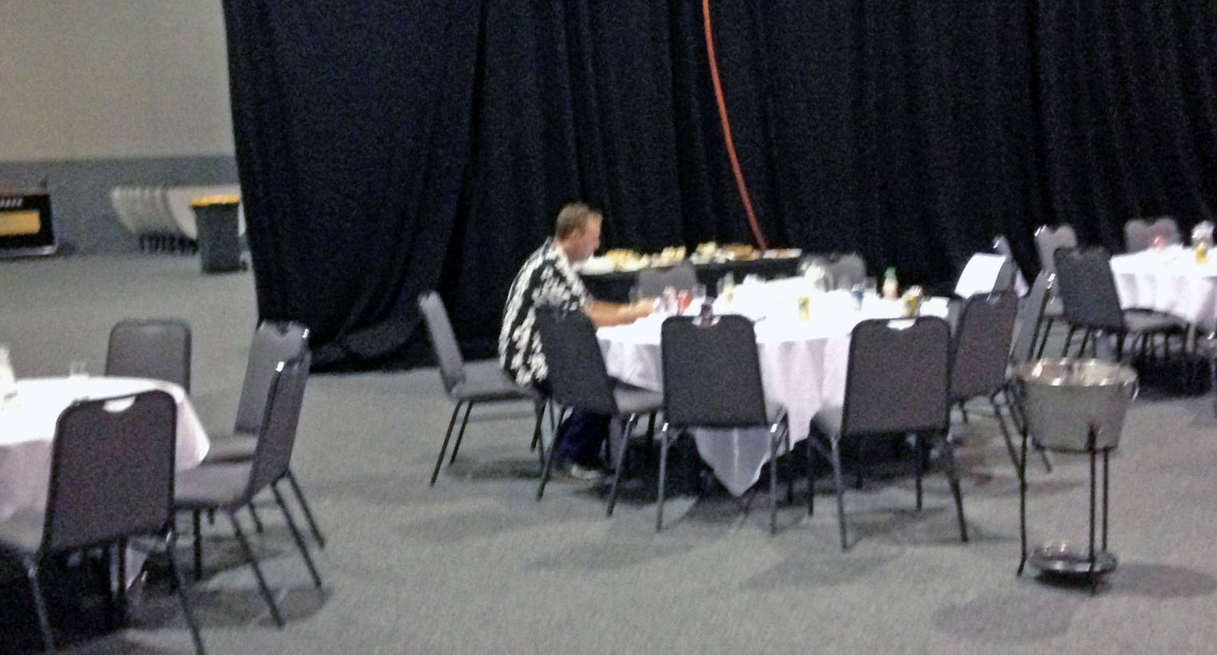

Rotary Club of Darwin Board 2015-2016*
President: Scott Perkins* Vice President: Jeff Swann*
Past President: Dan Easton* President Elect: Mark Taylor*
Secretary: Ray Fauntleroy* Treasurer: Mick Murray*
[Asst. Sec. Steven Camilleri]
Paul Simon* Mick Myers* Ian Jackson* John Palamountain*

Sergeant at Arms: John Emslie Attendance: Ben Hockley
Directorates & Committees 2015 – 2016
Community  Service | Club  Administration | Youth,  International Service | Fellowship, Vocational | Rotary Foundation, Fundraising
DIRECTOR  Mark Taylor  Assistant Director  Steve Jose | DIRECTOR  Paul Simon  Assistant Director  Dave Kingston | DIRECTOR  Mick Myers  Assistant Director  Andrew Pinnell | DIRECTOR  Ian Jackson  Assistant Director  Aidan McCaw | DIRECTOR  John Palamountain  Assistant Director  Grant Lindsay
Rotary Junior Sports Foundation  & AGFR  Wayne Nicholls  Jim McNally  Dave Kingston  Hugh Bradley | Membership  Retention, Development, Classification  Jeff Swann  Barry George | International Service including ROMAC, Interplast, RAWCS  Vic Minchin  Ray Fauntleroy  Matthew Baker  David Pearson | Fellowship, Social, Vocational Service, Away Meetings,  Aidan McCaw  Jeff Swann  Chris Tuck | ARHRF Programs,  Polio, Scholars World Community Service  Steve Baddeley  Peter Hopton
Police Officer of  the Year Award  Paul Simon  Peter Davies  Wayne Taylor  Al Wagner | Attendance  Ben Hockley  Al Wagner  Henry Duncan | Youth  Exchange Program  Andrew Pinnell  Steve Jose  Mick Myers | Club Program,  Me Talks  John Palamountain  Rob Trenerry  Mark Nacey  Henry Duncan  Terry Unthank | Chocolate Wheel  John Emslie  Charlie Dickman  Ben Hockley  John Brears
Ladies Long Lunch  Peter Hopton  John Brears  John Emslie  Steven Camilleri  Ian Jackson  Mick Murray | Sergeant at Arms  John Emslie  Ken Middlebrook  Aidan McCaw | NYSF/ Siemens Science School  Prath Prathapan | Guest Speakers  Ian Jackson  Steven Camilleri  Vic Minchin | Rotary Foundation  & Fund Raising  Greg Need  Ken Middlebrook  Jim Grierson  Lloyd Stevens  David Pearson
Ian MacGregor  English Awards  Mick Myers  Iain Smith  Bill Overton | Website, Facebook, Public Relations,  Wayne Taylor  John Emslie  Iain Smith  Dave Kingston  Steven Camilleri | Rotaract,  Interact  Andrew Pinnell  David Kingston  Barry George
Beat Foundation  Mick Myers  Barrie George  Jeff Swann  Jim Grierson | Governance  Wayne Taylor  John Emslie  Iain Smith  Ian Jackson | RYDA  Prath Prathapan  Grant Lindsay
Remote Community Support  Peter Hopton  Charlie Dickman  Ken Houghton | Club History  Ray Fauntleroy  Iain Smith  Kerry Ambrose-Pearce | RYLA  Grant Lindsay
Club Almoner  John Hartree | Club Bulletin  Iain Smith  Mick Myers  Andrew Pinnell  Henry Duncan | Beat Foundation  Mick Myers  Barry George  Jeff Swann
Safety, Insurance, Risk Management
John Emslie

